CM1016 Coursework Report  
Part 2

{GROUP 9}

{GROUP NAME}

Lewis Harrow – 1503809

Andrew Johnston – 1606303

El-Said Mkishk - 1603876

Rohan Hutcheon – 1602725

Rory Johnston – 1504553

Cameron Hay – 1607559

Table of Contents

1 Website Links 1

• https://lharrow.github.io/Homepage.html 1

• https://lharrow.github.io/Courses.html 1

• https://lharrow.github.io/Staff.html 1

• https://lharrow.github.io/News.html 1

• https://lharrow.github.io/Contact.html 1

1.1 GitHub Pages Link 1

• https://github.com/lharrow/lharrow.github.io.git 1

1.2 GitHub Link 1

• https://github.com/lharrow/RealCoursework.git 1

2 Pages Implemented 2

2.1 Page A - Homepage 2

2.2 Page B – Courses 2

2.3 Page C – Staff 2

2.4 Page D – News 2

2.5 Page E – Contact 3

3 Differences between Original and Implemented Design 3

3.1 Difference A 3

3.2 Difference … 3

4 Teamwork Breakdown 4

4.1 Github Contributions 4

# Website Links

# <https://lharrow.github.io/Homepage.html>

# <https://lharrow.github.io/Courses.html>

# <https://lharrow.github.io/Staff.html>

# <https://lharrow.github.io/News.html>

# <https://lharrow.github.io/Contact.html>

*** There are other pages within the website, but can be accessed through the main pages listed ***

## GitHub Pages Link

## <https://github.com/lharrow/lharrow.github.io.git>

## GitHub Link

## <https://github.com/lharrow/RealCoursework.git>

# Pages Implemented

We have created our website with various pages implemented throughout. There are five main pages in total (including the homepage), with 21 pages that can be accessed through each main page. We have implemented our website with thoughts towards accessibility, maintainability and ease of use.

## Page A - Homepage

This is the page that our users will first see when they click on the RGU website. Because of this we aimed for a look that is simple, yet effective. We have a navigation bar that allows the user to see the main aspects of the website. From here, they can click any of the headers, eg, ‘Courses’ or ‘Staff’, which will take them to the appropriate page. There is a banner image, with text inside, to show the user the campus, along with the overall section of the website they are on (School of Computing). This is used throughout all main pages to retain consistency­­­ in our website. The remainder of the website is the ‘body’ section, which contains the information (lorem ipsum is used throughout). All the information is enclosed within containers, which gives a more professional look to the website. Images are provided to make the website look more friendly and eye0-catching, along with keeping the user captivated. We have made use of large headings and relatively large text to allow all users to see our website, no matter their visual impairment. This ensures that no users are restricted from viewing our website.

## Page B – Courses

This page allows users to view the courses they could be potentially studying. It follows the same initial structure as all other main pages; navigation bar and banner image with text within. This again, shows consistency, which can be helpful for some users. There is also a navigation bar, with 6 pages that stem from this page. The side navigation bar gives options for users to be more specific in the type of courses information they require, eg, undergraduate, postgraduate etc. There is also information regarding some of the many courses offered at RGU. This page is clean, with a good amount of information without being cluttered. This is important because pages can very easily become cluttered with too much information, which can make it very hard to find relevant information. By keeping the webpage formative yet not full of information is guarantees users can easily find the information they are looking for.

## Page C – Staff

This page allows users to view the staff of RGU. It allows, for example, students to see who they may have for future lectures, or if they need help regarding specific subject fields. This page also has the navigation bar and banner image with text inside, which allows users to navigate between all pages on the website with ease. The page also has a side navigation bar which allows users to find out specific information about the staff of RGU. The remainder of the page is used for displaying the staff of RGU, which allows users to see staff members and some general information about them. Throughout the website we have made use of colours that are neutral and not too vibrant. This was to ensure there were minimal colour-blind users being unable to see aspects of our website. By using the colours we have, it has ensured that users will not get distracted by our colour scheme and not take the information in.

## Page D – News

This page allows users to view any news and events regarding RGU. This is of course news and events related to computing, which can be very useful to many users. The top of the page sees the navigation bar, which allows easy navigation through our website. Underneath the navigation bar is the header with text within. We then have the sidebar navigation which allows users to go into more specific areas of this website. There are four pages that stem off of this page, each offering different information to the user. The main body of the page has computing news, along with computing events. Both can be informative to the user, giving them knowledge on the computing world.

## Page E – Contact

This page allows users to find all of the contact information they need if they ever need to get in contact with the university. This could be vital for, eg, prospective students who wish to find out information about a course they could soon be studying. There is once again the navigation bar with a banner image and text inside. There is also the usual side navigation bar with 5 pages linked to the contact page, which gives users information on how to find them, along with emergency contact details. There is also the standard phone number and email provided, which is always useful for users wishing to get in touch. Underneath this information is arguably the most important, ways to follow RGU. This may not seem important, however it allows, eg, future students the opportunity to follow RGU on social media. This is an excellent and easy way to keep up with everything RGU does, which can make you more equipped and aware for studying with us. Finally, there is a in-browser map. This is a simple way for users to quickly find out where RGU is, which is imperative for, eg, open days or visits. The fact that it is built in to the webpage means that users are not required to open a new tab/window to find out this information.

# Differences between Original and Implemented Design

## Difference A

Lorem ipsum dolor sit amet, consectetur adipiscing elit, sed do eiusmod tempor incididunt ut labore et dolore magna aliqua. Ut enim ad minim veniam, quis nostrud exercitation ullamco laboris nisi ut aliquip ex ea commodo consequat. Duis aute irure dolor in reprehenderit in voluptate velit esse cillum dolore eu fugiat nulla pariatur. Excepteur sint occaecat cupidatat non proident, sunt in culpa qui officia deserunt mollit anim id est laborum.

## Difference …

Lorem ipsum dolor sit amet, consectetur adipiscing elit, sed do eiusmod tempor incididunt ut labore et dolore magna aliqua. Ut enim ad minim veniam, quis nostrud exercitation ullamco laboris nisi ut aliquip ex ea commodo consequat. Duis aute irure dolor in reprehenderit in voluptate velit esse cillum dolore eu fugiat nulla pariatur. Excepteur sint occaecat cupidatat non proident, sunt in culpa qui officia deserunt mollit anim id est laborum.

# Teamwork Breakdown

We used GitHub to store our website code, which meant that all members of our group had access to the most up to date version of the code. We did find that different members in our team had different skills, and were more comfortable doing different aspects of the website. We quickly split our group into those who would code the HTML, and those who would code the CSS. However, as time progressed the workload was not split evenly, with some members completing more work than others. This is reflected in the GitHub Contributions graph below. Other members (Cameron) contributed to the HTML and CSS of the website, however we had issues with using GitHub on everybody’s computers.

## Github Contributions

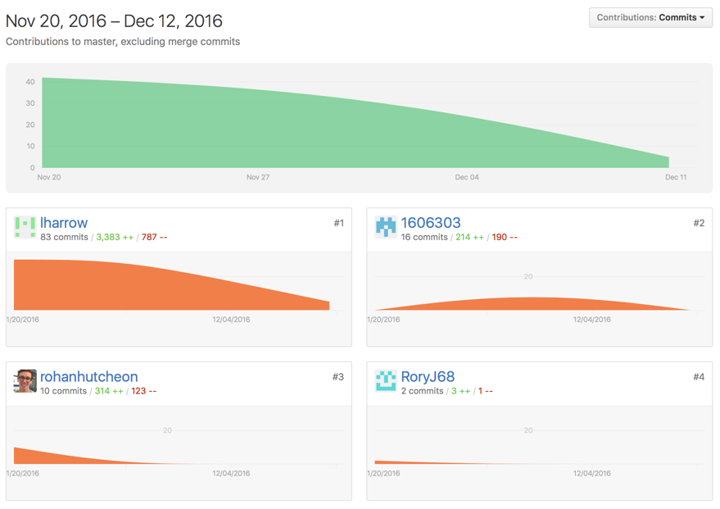

Lewis Harrow’s (1503809) contributions – From the beginning, I decided to be part of the team executing the HTML for our website, as this is where I am stronger in terms of coding. It was decided that I would code the structure of the website with two members, with the CSS being completed by three other members. I was to code the HTML with two other members of the larger group, but received very little help. I started on the 20th November, and continued the HTML well into December for completing this section. The initial CSS was completed, with it needing updated as I had added more code after the CSS had been introduced. I largely completed the CSS, with other members helping near the end with regards to containers and overall design. Overall, I feel as though I completed much of this coursework myself, with minimal help from my group.